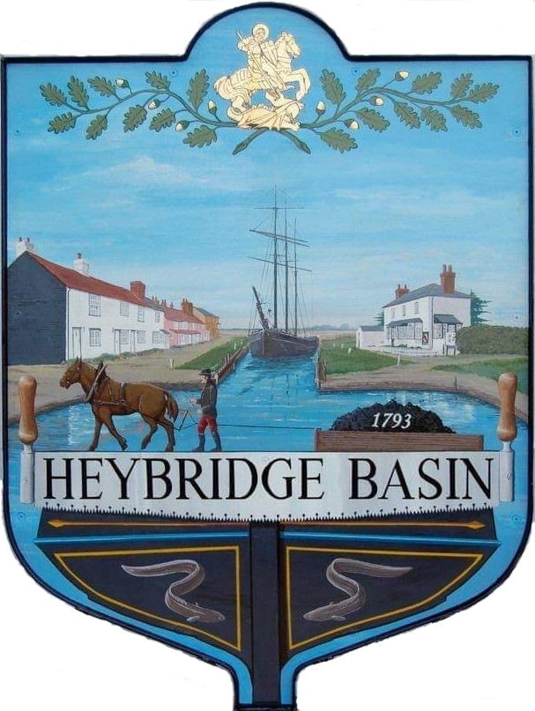

HEYBRIDGE BASIN PARISH COUNCIL
COUNCILLORS

2023/2024

Martyn Hodges (Chair)
Email: martynhodges@heybridgebasinpc.org.uk

Rob Bryson (Vice Chair)
Email: robbryson@heybridgebasinpc.org.uk

Jenny Sjollema
Tel: 07903 347782

Email: jenny@heybridgebasinpc.org.uk

Colin Edmond
Email: colinedmond@heybridgebasinpc.org.uk

Graham Howat
Tel: 07710 048974
Email: grahamhowat@heybridgebasinpc.org.uk

Marion Hobden
Email: marionhobden@heybridgebasinpc.org.uk

Clint Swann
Email: clintswann@heybridgebasinpc.org.uk

